RemoTITM IR Signal Generation Application Note
By Stig Torud

Keywords

- RemoTITM
- CC253x
- Infrared (IR)
- ZigBee RF4CE
- ZigBee Remote Control (ZRC)
- Target Board

Introduction

Although ZigBee RF4CE based remote controllers are replacing traditional IR remote controllers at a fast pace, manufacturers of RF4CE remote controllers may still want to support IR to control legacy consumer electronics equipment.

The CC2530 and CC2533 devices used in RF4CE applications provide hardware support for generation of IR signals with minimal CPU intervention. This enables RF4CE remote control manufacturers with a cost effective approach to support legacy consumer electronics equipment.

This application note provides information for how use this hardware capability in the RemoTI software environment and also sample implementation of three different IR encoding format.

The objective of this application note is not to provide the command database for the different IR formats, rather, to educate the reader to be able to use the hardware capabilities for their desired format based on the sample implementations provided.

RemoTI is Texas Instrument’s implementation of the ZigBee RF4CE network protocol standard. You can find more information about RF4CE at www.zigbee.org/rf4ce and RemoTI at www.ti.com/RemoTI.

Table of Contents

Keywords 1
1 Introduction 1
2 Abbreviations 3
3 Introduction to IR Signals 4
3.1 NEC IR Format 4
3.1.1 Modulation 4
3.1.2 Protocol 4
3.2 Repeat Sequence 5
3.3 RC5 Format 5
3.3.1 Modulation 5
3.3.2 Protocol 6
3.3.3 Repeat Sequence 6
3.4 SIRC Format 7
3.4.1 Modulation 7
3.4.2 Protocol 8
3.4.3 Repeat Sequence 8
4 IR signal generation with CC253X 8
4.1 Non-modulated Signals 9
4.2 Modulated Signals 9
4.3 Timer and DMA Interaction Examples 10
4.3.1 Pulse Distance Encoding 11
4.3.2 Pulse Width Encoding 12
4.3.3 Manchester Encoding 13
4.3.4 Start and Stop Conditions 14
5 IrGenApp 14
5.1 IAR Workspace 14
5.2 Architecture 14
5.3 NEC format 14
5.3.1 Bit Timing Calculation 14
5.4 RC5 format 14
5.4.1 Bit Timing Calculation 14
5.5 SIRC format 14
5.5.1 Bit Timing Calculation 14
5.6 Buttons and LEDs 14
5.7 Execution Sequence 15
5.8 Observing IR Generated Signal 15
5.9 IR Generation Scope Traces 15
5.9.1 NEC Format 15
5.9.2 RC5 Format 15
5.9.3 SIRC Format 15
6 Integrating IR signal Generation in Custom Solution 15
7 Execute the Application 15
8 Limitations 15
9 References 17
10 General Information 18
10.1 Document History 18

Abbreviations

EM Evaluation module
LED Light Emitting Diode
IR Infrared
ISR Interrupt Service Routine
LSB Least Significant Bit
MAC Medium Access Control
MSB Most Significant Bit
RAM Random Access Memory
RF Radio Frequency
RF4CE Radio Frequency for Consumer Electronics
OSAL Operating System Abstraction Layer
HAL Hardware Abstraction Layer
NV Non-Volatile (memory)
ZRC ZigBee Remote Control

Introduction to IR Signals
A wide variety both standard and proprietary IR signal formats is used in consumer electronics equipment. The IR formats can’t be divided into three main categories or combinations of these;

- Pulse distance modulation
- Pulse width modulation
- Manchester (bi-phase) modulation

The pros and cons of the different modulation techniques will not be discussed in this application note; however, we will discuss their differences and how to use CC253x family of devices to generate the IR formats. The NEC, RC5 and SIRC formats are used as examples of the different formats and the sample drivers and applications accompanying this application note implements these three formats. [1] is used as the reference for the details of the modulation formats.

NEC IR Format

Modulation

The NEC format uses the pulse distance modulation technique. Pulse distance modulation is based on varying the pulse duty cycle for a logical “1” and “0” while keeping the pulse active period constant. Figure 1 below illustrates the principle of pulse distance modulation.

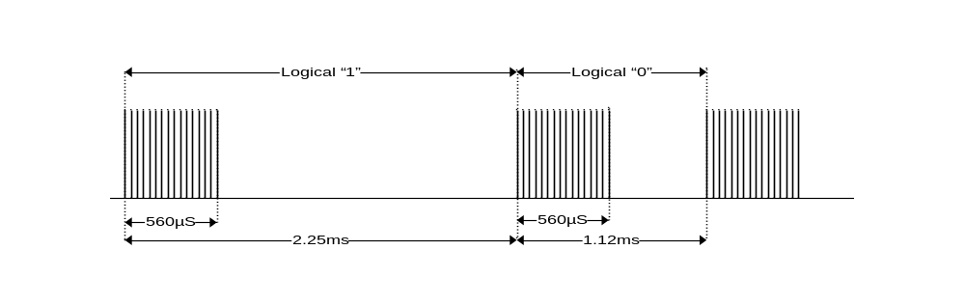
Figure 1 NEC Format - Pulse Distance Modulation

NEC format timing information:
- Carrier: 38 kHz with 1/3 or 1/4 duty cycle
- Active period: 560 µS
- Duty Cycle
  - Logical “1”: 2.25 ms
  - Logical “0”: 1.12 ms.

Protocol

The NEC protocol uses 8 bit command and 8 bit address length for each transfer. The command and address bits are preceded by a preamble with active period of 9 ms and duty cycle of 13.5 ms. The command and address bits are transfer a second time with all bits inverted for increased reliability. Each command and data byte are transferred with the LSB first. A trailing stop bit is used to indicate the end of frame. See Figure 2 below for an illustration of the protocol.

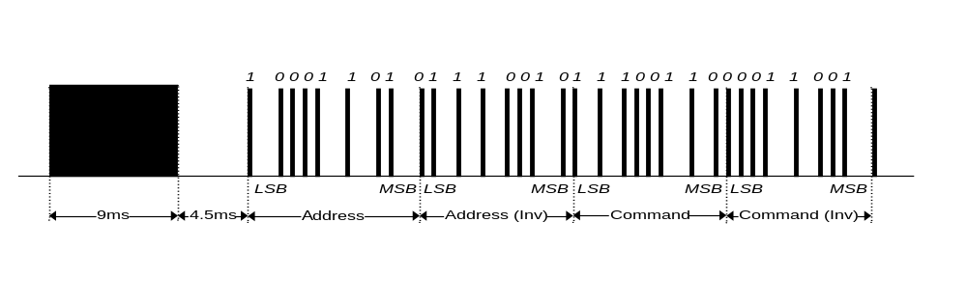
Figure 2 NEC Protocol

Repeat Sequence

The protocol described in Figure 2 is transmitted once. A repeat pattern consisting of a preamble of active period 9 ms and duty cycle 11.5 ms, and a stop bit is transmitted every 110 ms as long as the key is remains pressed. Note that the preamble duty cycle of the repeat pattern is shorter than the preamble of the first command and data frame. See Figure 3 below for an illustration of the repeat sequence.

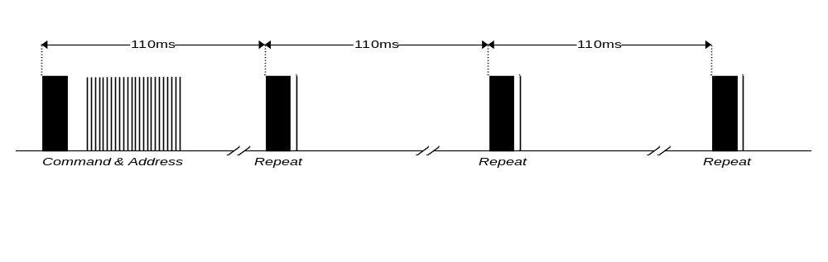
Figure 3 NEC Repeat Sequence

RC5 Format

Modulation

The RC5 format uses the Manchester (bi-phase) modulation technique. Manchester modulation is based on keeping the pulse active period and duty cycle constant while time constant while positioning the pulse at the beginning or the end of the duty cycle to distinguish between a logical “1” and “0”. Figure 4 below illustrates the principle of Manchester modulation.

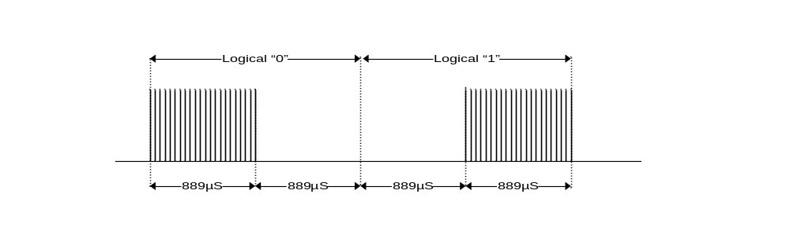
Figure 4 RC5 Format - Manchester (Bi-phase) Modulation

RC5 format timing information:
- Carrier: 36 kHz with 1/3 or 1/4 duty cycle
- Active period: 889 µS
- Duty Cycle: 2 * Active Period: 1.778 ms
  - Logical “0”: Active burst first half of duty cycle
  - Logical “1”: Active burst in second half of duty cycle

Protocol

The RC5 protocol uses 6-bit command and 7-bit address length for each transfer. Other versions with different command and address length also exist. The RC5 protocol is not using a preamble; instead two start bits of logical “1” are used to identify the start of a frame. The third bit is a toggle bit that is inverted every time a key is pressed. This way the receiver can distinguish between a key pressed command and repeated commands. The command and data bits are transferred with the MSB first. See Figure 5 below for an illustration of the protocol.

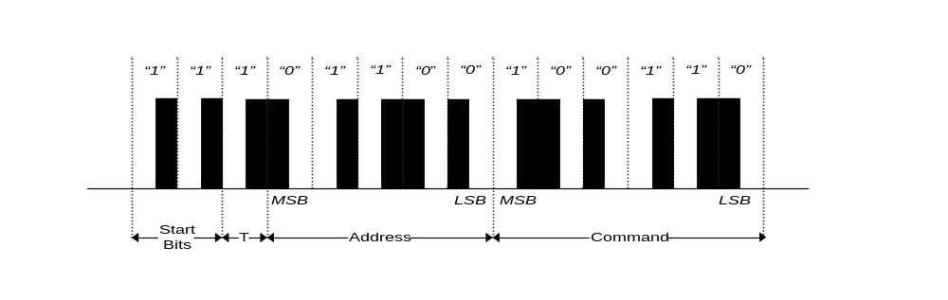
Figure 5 RC5 Protocol

Repeat Sequence

The protocol described in Figure 5 is also used as the repeat pattern. This means initial frame and repeat frames are identical. The frame is repeated every 114 ms as long as the key remains pressed. See Figure 6 for an illustration of the repeat sequence.

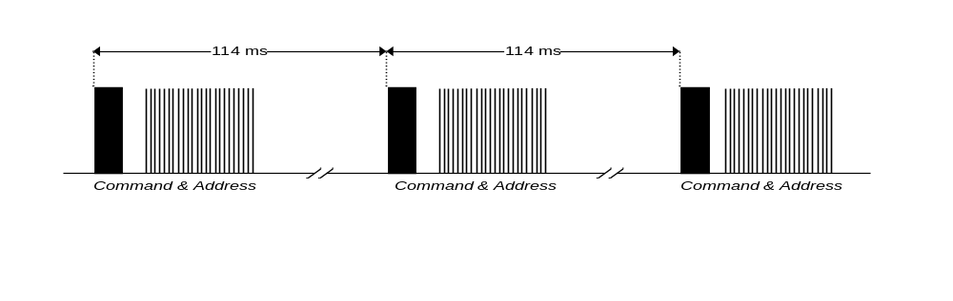
Figure 6 RC5 Repeat Sequence

SIRC Format

Modulation

The SIRC format uses a combination of the pulse distance and pulse width modulation technique. SIRC modulation is based on varying both the active period and duty cycle to distinguish between a logical “1” and a logical “0”. Note that the non-active period for both logical “1” and logical “0” is constant. Figure 7 below illustrates the principle of a combined pulse distance and pulse width modulation

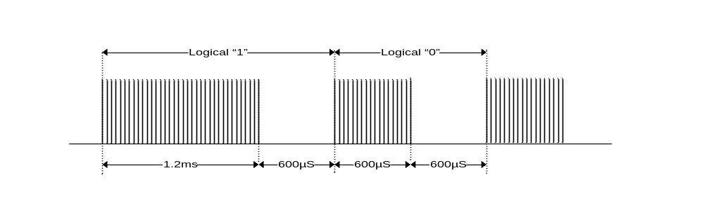
Figure 7 SIRC format - Pulse Distance and Pulse Width Modulation

SIRC format timing information:
- Carrier: 40 kHz with 1/3 or 1/4 duty cycle
- Active period:
  - Logical “0”: 600 µS
  - Logical “1”: 1.2 ms
- Duty Cycle
  - Logical “0”: Active Period Logical “0” + 600 µS: 1.8 ms
  - Logical “1”: Active Period Logical “1” + 600 µS: 1.2 ms

Protocol

The SIRC protocol uses 7-bit command and 5-bit address length for each transfer. Other versions with different command and address length also exist. The command and address bits are preceded by a preamble with active period of 2.4 ms and duty cycle of 3 ms. The command and data bits are transferred with the LSB first. See Figure 8 below for an illustration of the protocol.
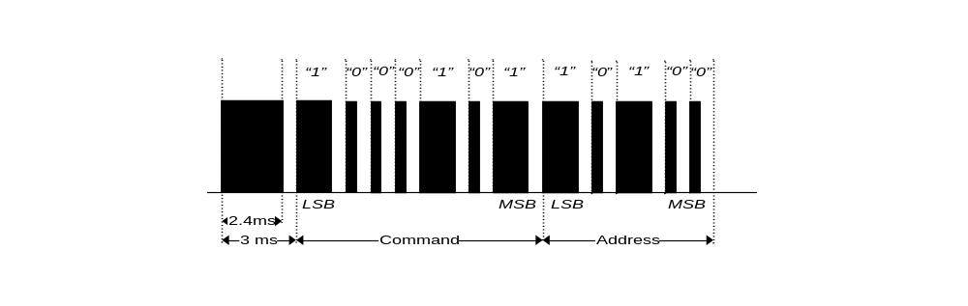
Figure 8 SIRC Protocol

Repeat Sequence

The protocol described in Figure 8 is also used as the repeat pattern. This means initial frame and repeat frames are identical. The frame is repeated every 45 ms as long as the key remains pressed. See Figure 9 for an illustration of the repeat sequence.

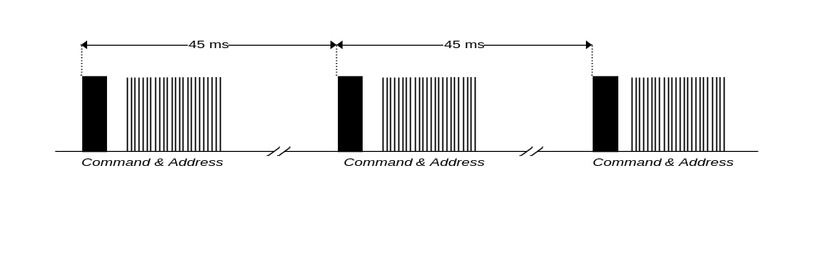
Figure 9 SIRC Protocol Repeat Sequence

IR signal generation with CC253X
The CC253x family of devices contains hardware feature that enables generation of IR signals with minimal CPU interaction. The following resources are available;

- Timers
  - Timer 1 (16 bit)
  - Timer 3 (8 bit)
  - Timer 4 (8 bit)
- DMA
  - Multiple DMA channels for transfer of IR signal timing data to the timers
- IR generation AND circuit
  - Logical AND circuit used to combine two timer outputs to generate a modulated IR signal. Note that only Timer 3 and Timer 1 can be used for this purpose

Note that Timer 2 (MAC timer) can’t be used for this purpose as it is used to control the timing of the 802.15.4 MAC.

Non-modulated Signals

Non-modulated signals can be generated using Timer 1 (T1), Timer 3 (T3) and Timer 4 (T4) together with DMA channels for minimal CPU interaction. Which timer to use depends on the timing specification of the IR signal and the output pin requested for the generated signal. See [2] for details of output pin assignments of the different timer channels.

Modulated Signals

Modulated signals are generated using Timer 1 (T1) and Timer 3 (T3). T1 is used to modulate the IR signal on top of the carrier generated by T3. Note that only Timer 1 channel 1 output and T3 channel 1 output can be combined with the logical AND circuit to generate a modulated IR signal. The IR OUT pin is controlled by the T1 channel 1 output pin and is as such limited to P1.1 or P0.3. See the peripheral I/O section of [2] for details. P1.1 has 20 mA drive strength while P0.3 has 4 mA drive strength. Figure 10 below illustrates the logic for generation of modulated IR signals.

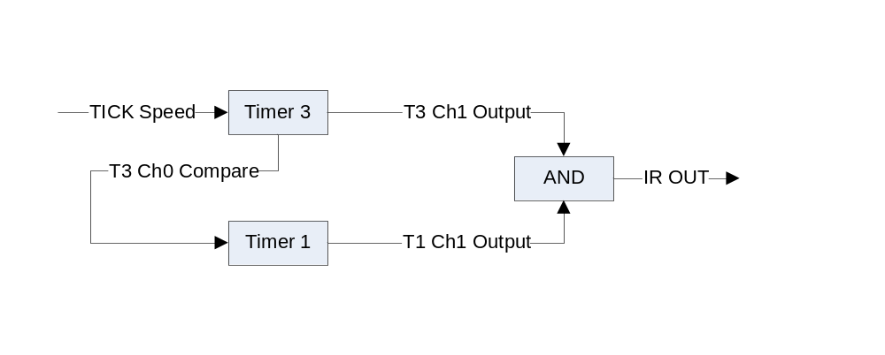
Figure 10 CC253x IR Generation HW for Modulated Signals

NOTE that the IR OUT is active high. This means that external circuitry for increased drive strength and range or IR signal must be designed with active high logic.

Timer and DMA Interaction Examples

The modulo mode and output compare mode feature of Timer 1 (T1), Timer 3 (T3) and Timer 4 (T4) are used to control pulse generation compromising the IR signal. These features are described in details in the chapter for each timer in [2], however, here a short description of these important features.

- Timer modulo mode
Timers can be configured as free running, up/down or modulo mode. The modulo mode basically configures the timer to count upwards from 0x0 to the value configured in the timer channel 0 compare register. The timer wraps around to 0x0 again when the timer channel 0 compare register value is reached. This feature is used to control the duty cycle of each pulse in the IR signal pattern.

- Timer output compare mode
Timer channel 1-n (n dependent on timer) is associated with an output pin in output compare mode. The output on this pin is controlled by which output compare mode is selected and current timer value. This application note and sample code is using output compare mode 4; the pin is set when timer counter is 0x0 and cleared when the timer counter value equals the timer channel 1-n compare value. This feature is used to control the active period of each pulse in the IR signal pattern.

An example is shown in Figure 11 where the timer channel 0 compare (CC0) is set to 4 and timer channel 1 output compare (CC1) is set to 2. The timer is furthermore configured to run in modulo and compare mode 4.

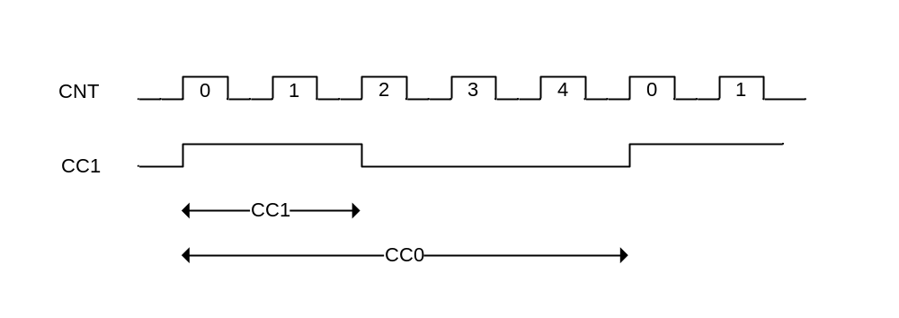

Figure 11 Timer Modulo and Compare Mode 4

It can be seen from Figure 11 that the pulse on Timer Channel 1 (CC1) is set when the timer counter (CNT) is 0x0 and cleared when it the CNT=CC1. The CNT also wraps around and starts counting upwards from 0x0 when CNT=CC0.

It is important to note the effect of the 0th counter cycle on the generated signal. One may expect a 50% duty cycle when CC1 is configured to CC0 /2, however, the generated signal duty cycle is actually CC1 / (CC0 + 1). It is therefore important to configure the CC0 value with the 0th counter cycle in mind for correct timing.

The timer CC0 and CC1 values can be programmed manually or by using dedicated DMA channels. DMA channels are used to avoid CPU interaction from the time the signal generation is started until an interrupt is generated at the end of the complete IR signal generation. The DMA channels are configured to feed the CCO and CC1 register from a buffer in RAM with the timing information for each pulse. The RAM buffers are configured depending on the IR generation signal format timing and the address and data information for the command or repeat sequence.

The DMA channels are furthermore configured to trigger on the CC1 value of the timer. This means the next CC0 and CC1 value us transferred from RAM to the respective timer CC0 and CC1 registers when the timer CNT = current CC1 value. It is important to notice that these new DMA’d CC0 and CC1 values are not latched into the timer until the timer CNT = 0x0.

The DMA is configured to operate in variable length mode and the length, i.e. the number of CC0 and CC1 values to be transferred, is set for each IR command depending on the signal pattern. The DMA will generate an interrupt immediately after the last value is DMA’d from RAM to the timer CCO and CC1 register. In order to ensure generation of the last pulse, a last value in the RAM buffers are include as don’t care. Basically, the ISR will be called and the timers will be stopped after the last DMA. As such, the timing information of the last value I the RAM buffers will never be generated.

Pulse Distance Encoding

Figure 12 below illustrates the sequence of events for the timer and DMA channels for pulse distance encoding

- CNT shows the timer counter values
- The mid section shows the DMAs trigger when CNT=CC1 and the DMA transfer from buffer a and b to the CCO and CC1 timer registers respectively
- The latch arrow shows the point in time when the new CC0 and CC1 values are latched into the timers
- IR OUT is the generated signal

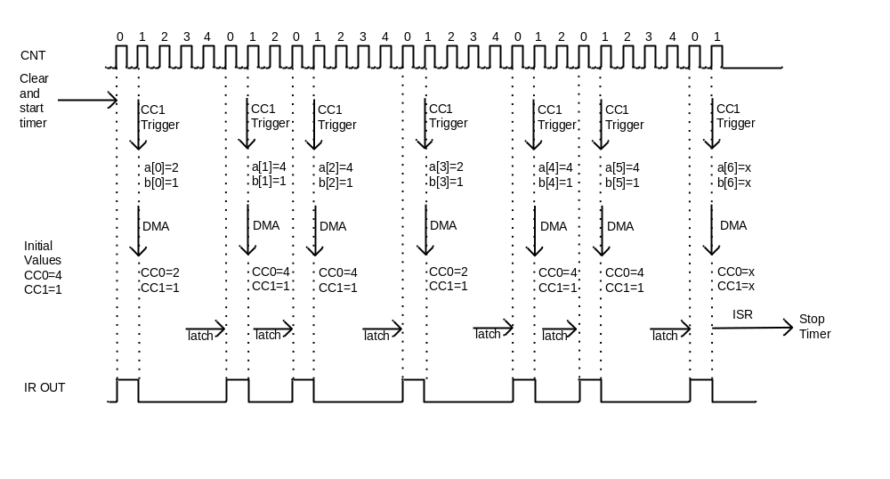
Figure 12 Pulse Distance Encoding: DMA and Timer Details

As seen from Figure 12, the CCO and CC1 register must be programmed with initial values to control the timing of the first pulse. The subsequent pulses are controlled with the timing information DMA’d from the RAM buffers.

This illustration uses one DMA channel each for the CCO and CC1 timing information. It can be observed that the CC1 value is constant. This is expected for pulse distance encoding where the pulse active period is constant while the pulse duty cycle period varies to distinguish between a logical “0” and “1”. As such, only one DMA channel is really necessary for pulse distance coding formats since CC1 doesn’t need to be re-programmed. Note, however, that IR coding formats that include a preamble must use a DMA channel for the CC1 timing information as well due to different active period timing of the preamble and the individual pulse. This is in fact the case for the NEC format described and implemented in the sample code for this application note.

Pulse Width Encoding

Figure 13 below illustrates the sequence of events for the timer and DMA channels for pulse distance encoding

- CNT shows the timer counter values
- The mid section shows the DMAs trigger when CNT=CC1 and the DMA transfer from buffer a and b to the CCO and CC1 timer registers respectively
- The latch arrow shows the point in time when the new CC0 and CC1 values are latched into the timers
- IR OUT is the generated signal

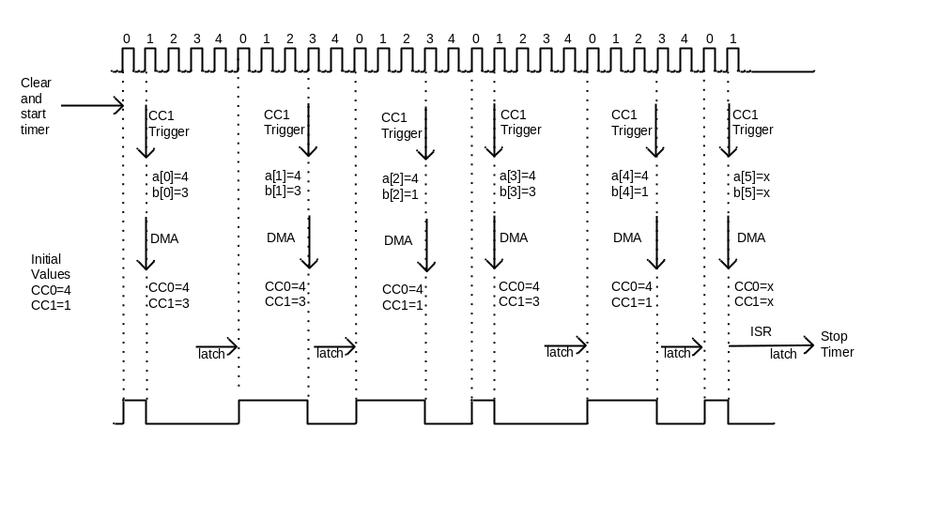
Figure 13 Pulse Width Encoding: DMA and Timer Details

As seen from Figure 13, the CCO and CC1 register must be programmed with initial values to control the timing of the first pulse. The subsequent pulses are controlled with the timing information DMA’d from the RAM buffers.

This illustration uses one DMA channel each for the CCO and CC1 timing information. It can be observed that the CC0 value is constant. This is expected for pulse width encoding where the pulse duty cycle period is constant while the pulse active period varies to distinguish between a logical “0” and “1”. As such, only one DMA channel is really necessary for pulse distance coding formats since CC0 doesn’t need to be re-programmed. Note, however, that IR coding formats that include a preamble must use a DMA channel for the CC0 timing information as well due to different active period timing of the preamble and the individual pulse.

Manchester Encoding

Figure 14 below illustrates the sequence of events for the timer and DMA channels for pulse distance encoding

- CNT shows the timer counter values
- The mid section shows the DMAs trigger when CNT=CC1 and the DMA transfer from buffer a and b to the CCO and CC1 timer registers respectively
- The latch arrow shows the point in time when the new CC0 and CC1 values are latched into the timers
- IR OUT is the generated signal

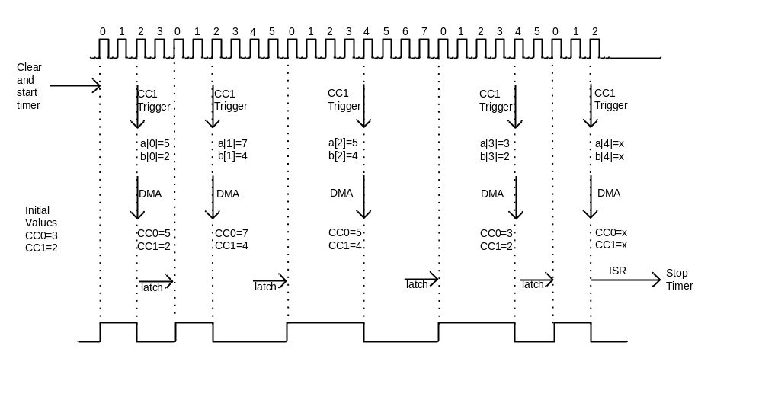
Figure 14 Manchester Encoding: DMA and Timer Details

As seen from Figure 14, the CCO and CC1 register must be programmed with initial values to control the timing of the first pulse. The subsequent pulses are controlled with the timing information DMA’d from the RAM buffers.

This illustration uses one DMA channel each for the CCO and CC1 timing information. It can be observed that the neither CC0 nor CC1 values are constant as with pulse distance or pulse width encoding. The values of CC0 and CC1 varies dependent on the sequence of logical “0’s and logical “1”s to be transmitted.

Start and Stop Conditions

Add text
- Roll timers in the init to ensure low output

IrGenApp

IAR Workspace
- project options

Architecture
Add text
- Init function
- Gen function
- Repeat function
- ISR and CB function

NEC format

Bit Timing Calculation

RC5 format

Bit Timing Calculation

SIRC format

Bit Timing Calculation

Buttons and LEDs

The S2 button on the Target Board is used as input to trigger discovery/pairing.

Two LEDs are used as visual indication of RemoTI initialization, discovery/pairing and IR generation.

- Green LED (LED1) is used to indicate message exchange.
  - Off – no valid pairing in the node paring table
  - On – at least one pairing entry exist in the node paring table
  - Blinking - indicates the node is in discovery mode and will accept discovery/pairing request from a remote controller node. The target node implements the CERC auto-discovery pairing mechanism and will as such accept pairing request for 30 sec after S1 is activated.
- Red LED (LED2) is used to indicate RemoTI initialization and IR signal generation.
  - On - when IrGenApp is initializing and when the during IR signal generation.
  - Off – when in ready state

Execution Sequence
- Build the project.
- Connect the mini USB cable to the Target Board to apply power.
- Connect the CC debugger and download the executable.
- Start the execution of the IrGenApp and observe the green LED turned on.
- Wait until the green LED is turned off to indicate that RemoTI stack has initialized.
- Press S1 to enable discovery/pairing mode and observe the green LED blinking.
- Press the pairing button on the remote controller when the green LED is blinking.
- The green LED will turn on solid when the pairing link is established.
- Press the ‘play’ key on the remote controller to start IR generation and observe the red LED blink when IR signal generation is in progress. Note that other keys pressed on the remote controller have no effect.

Observing IR Generated Signal

Add text :
- Target Board 1.0 (active low external circut by mistake). versus 1.1 (active high)

IR Generation Scope Traces

NEC Format

Include the scope traces

RC5 Format

Include the scope traces

SIRC Format

Include the scope traces

Integrating IR signal Generation in Custom Solution
- output pin selection

Execute the Application

Limitations

Add text
- any limitations?

References
- http://www.sbprojects.com/knowledge/ir/ir.htm
- CC253x User’s Guide, SWRU191 (www.ti.com/lit/swru191)
- http://focus.ti.com/docs/prod/folders/print/cc2530.html

General Information

Document History
Revision | Date | Description/Changes
SWRA286 | 2009.05.12 | Initial release.

